Clone the repository with latest changes:

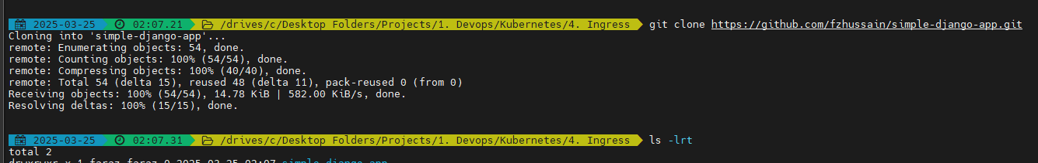

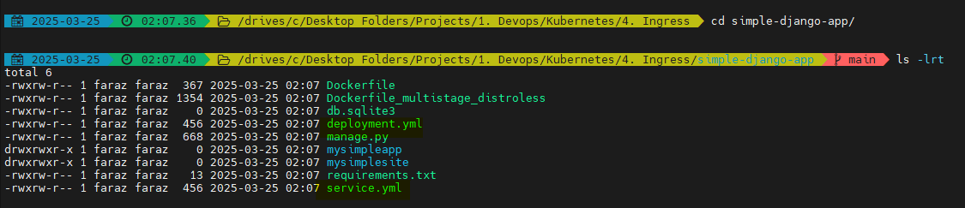

Make sure you have your setup till:

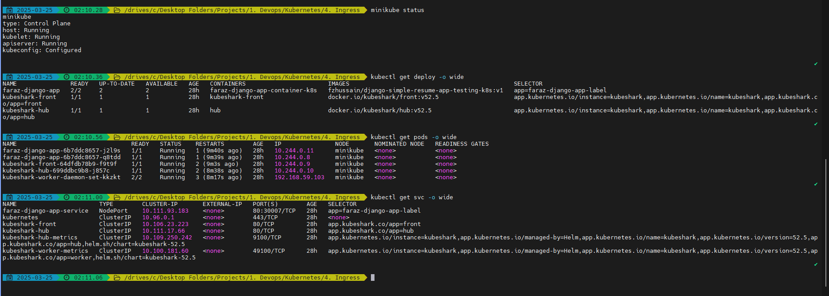

Ensure your application is running:

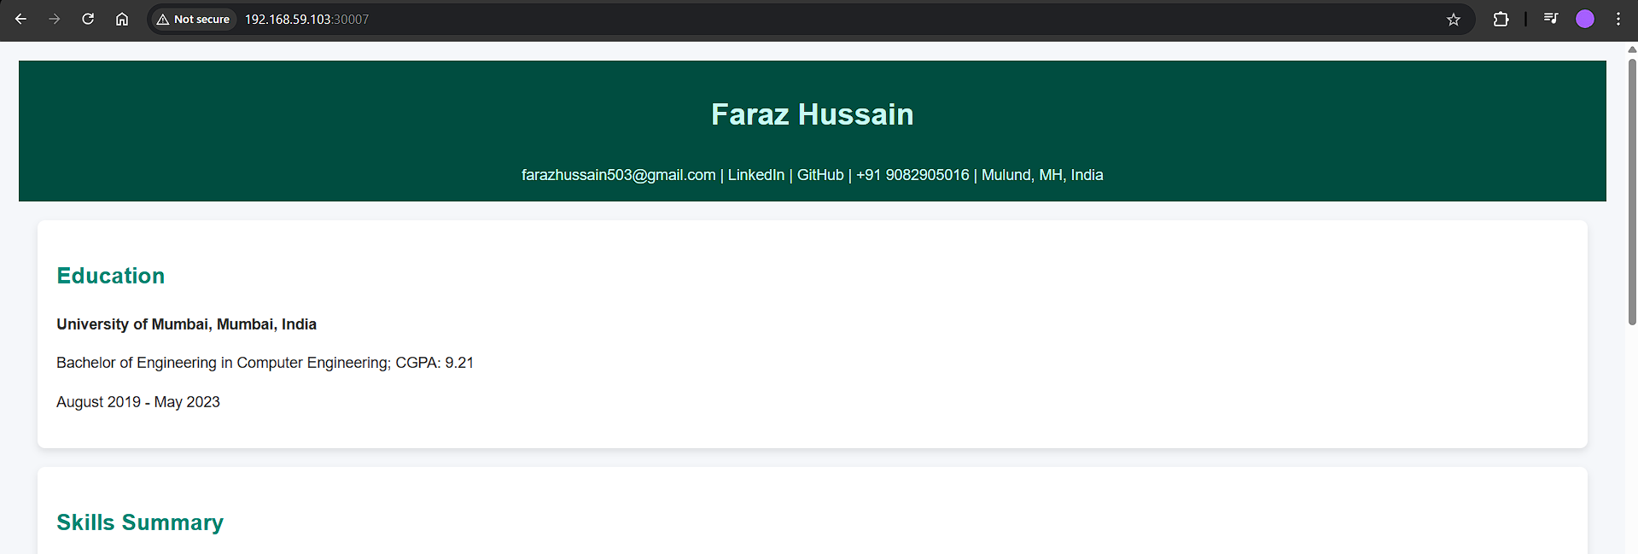

Now let us setup ingress and host based load balancing:

Got to: <https://kubernetes.io/docs/concepts/services-networking/ingress/>

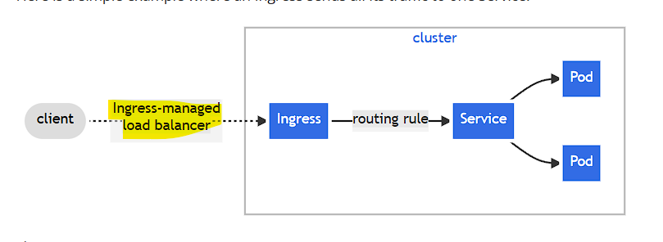

Ingress managed load balancer = ingress controller

Ingress = Ingress resource

Copy the below from the documentation:

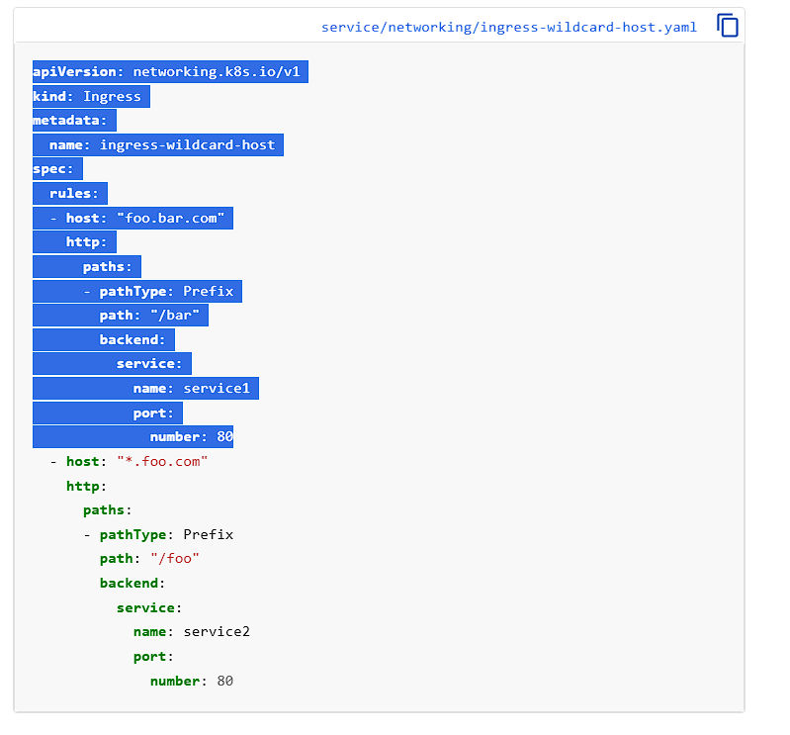

Create your ingress yaml manifest:

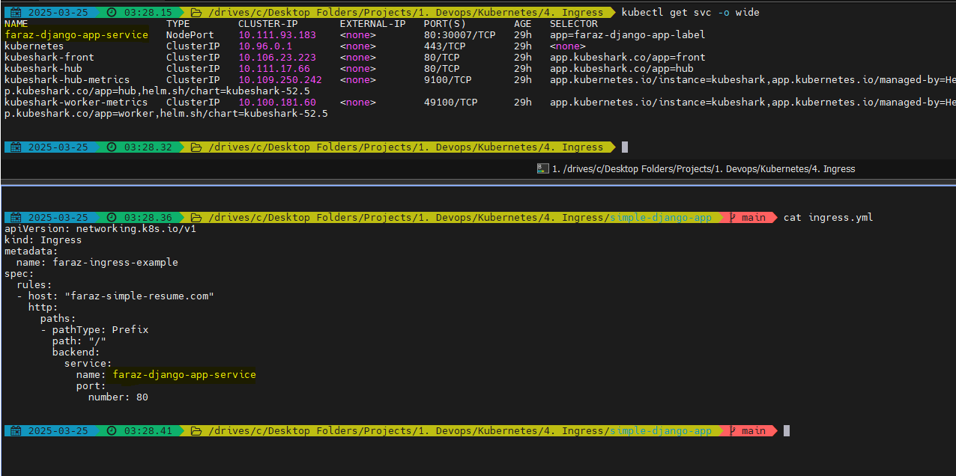

Create your ingress:

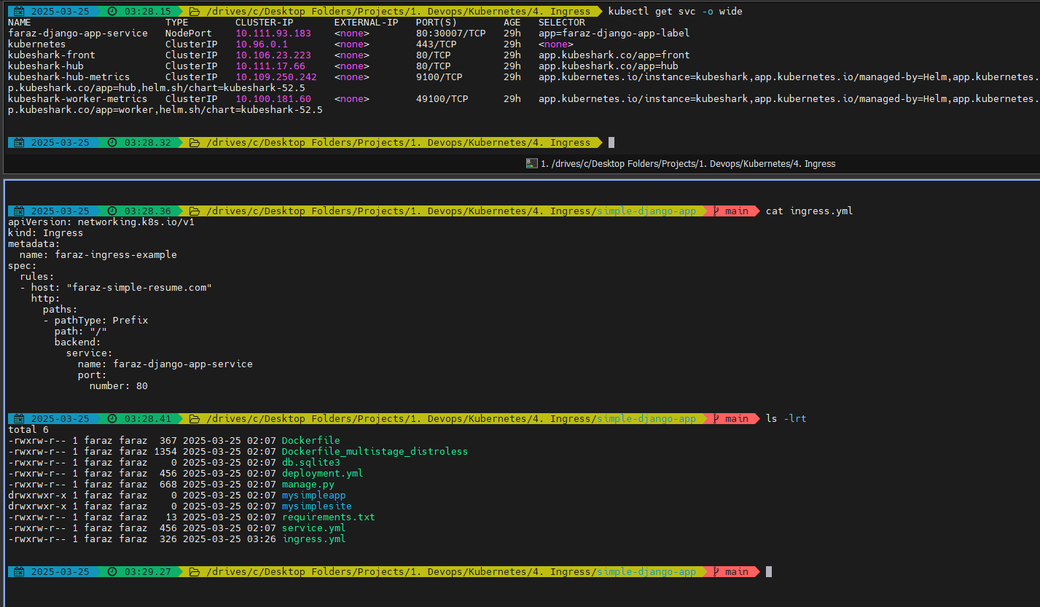

Deploy your ingress





Nothing will happen as there is no ingress controller:



Hence, install ingress controller (nginx)

If you are in production using EKS/Openshift:

Go to: <https://kubernetes.io/docs/concepts/services-networking/ingress-controllers/>

Download & follow steps provided online:

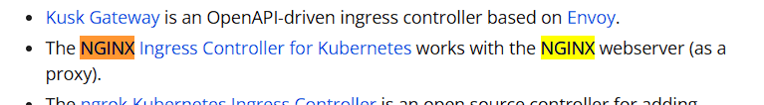

Example: <https://docs.nginx.com/nginx-ingress-controller/installation/installing-nic/installation-with-helm/>

If you are on Minikube:

Go to: <https://kubernetes.io/docs/tasks/access-application-cluster/ingress-minikube/>

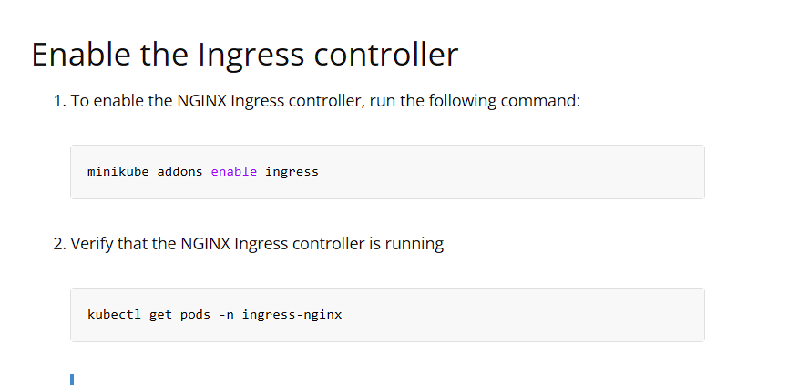

* minikube addons enable ingress

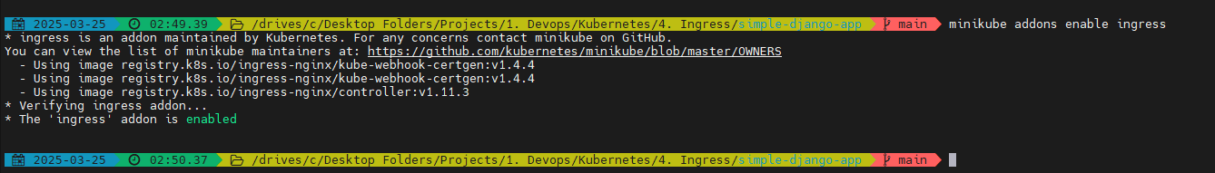

* kubectl get pods -A | grep ingress

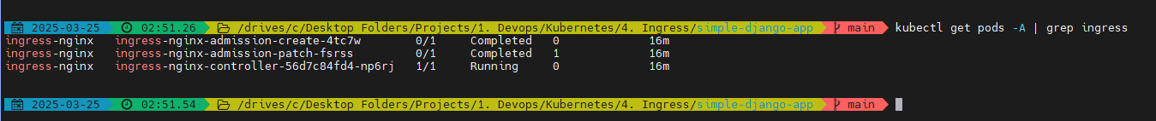

Now you will be able to see that the ingress-nginx controller is up and running

Now verify if ingress controller is able to see the ingress resource that it has created:

* kubectl logs ingress-nginx-controller-56d7c84fd4-np6rj -n ingress-nginx

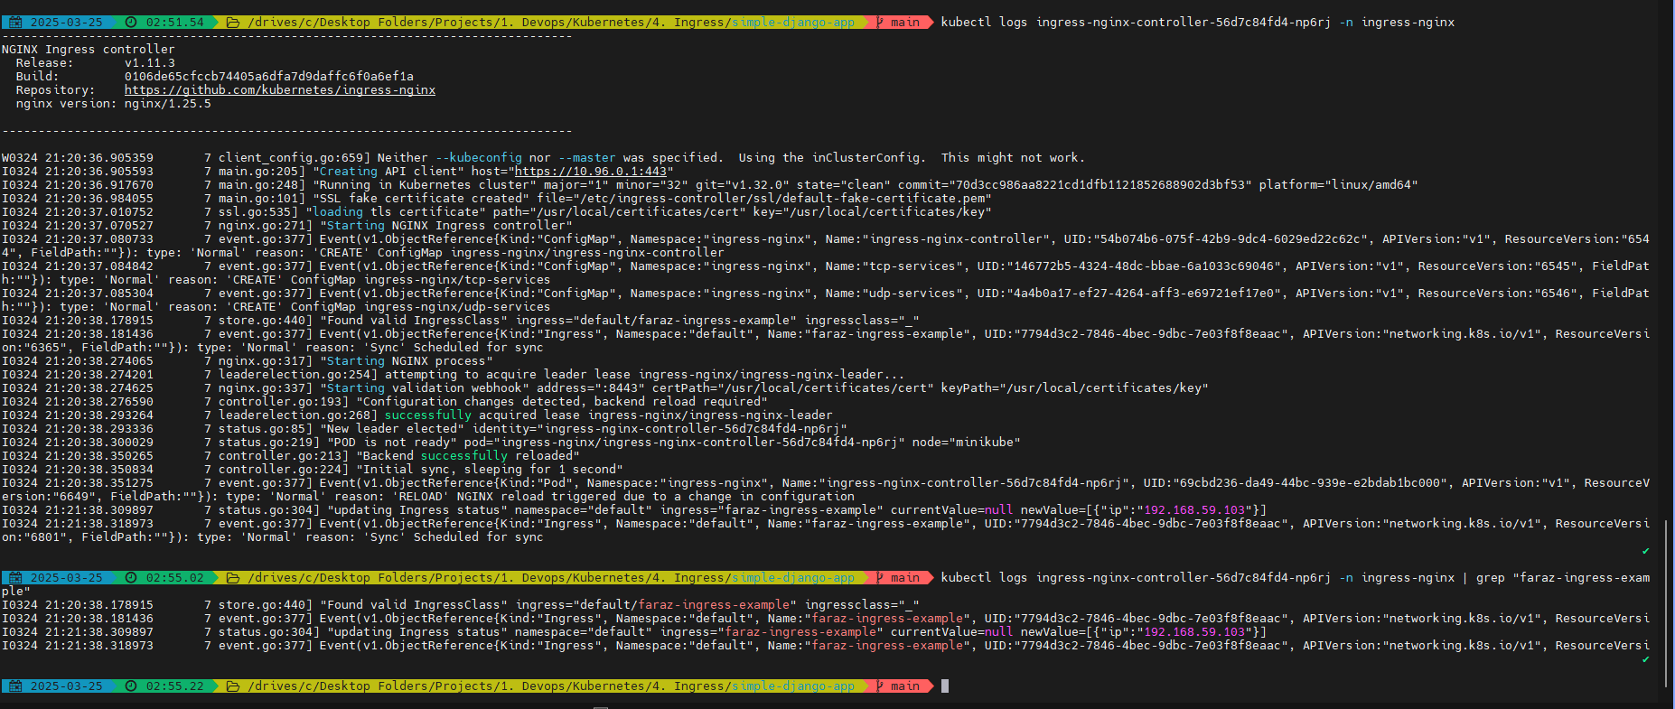

Now you will be able to see:

Previously:



Currently:

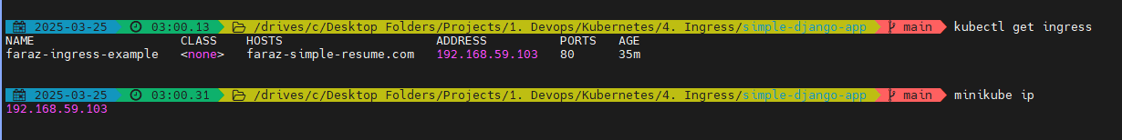

In production, at this stage, we are good so far.

But in local environment we may do the following:

Update the following file as domain mapping needs to be done on local:



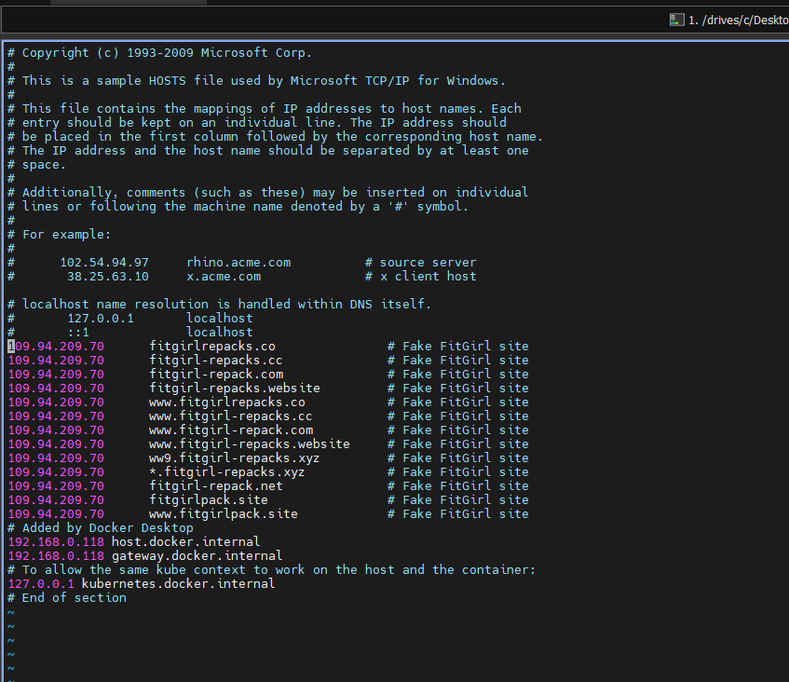

Add the IP:

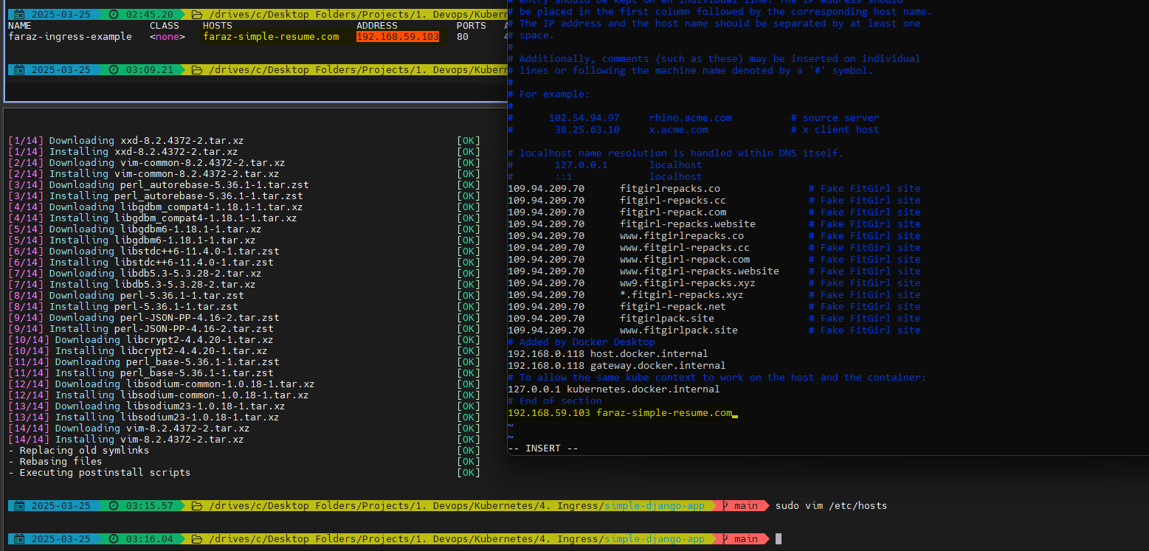

Your domain(faraz-simple-resume.com) is now mapped to IP 192.168.59.103

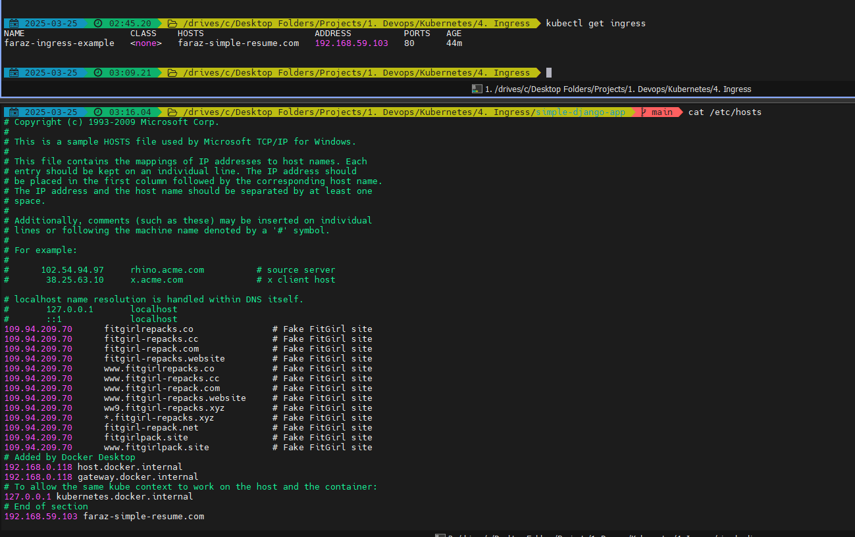

Now I will be able to access my application using on my local machine: <http://faraz-simple-resume.com/>

